Update 16 / Report 1
Saturday October 1, 2011

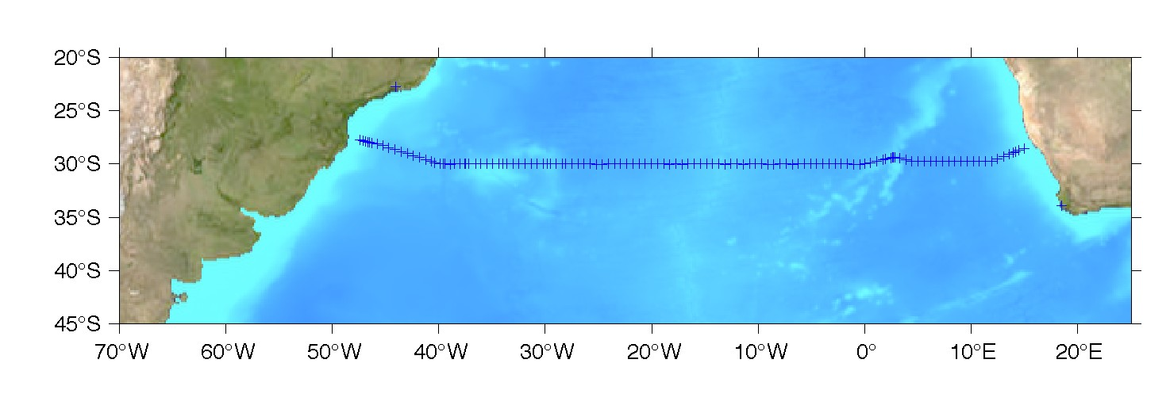
After five full days underway, the Clivar A10 cruise has finally gotten its “sea-legs” and we’ve completed 14 full-water column Stations. This cruise will occupy a series of about 124 deep ocean stations in the South Atlantic Ocean from about 15 degrees East to about 47 degrees west, along approximately 30 degrees South (see attached map). This section was previously occupied on an oceanographic expedition in 1992 and 2003. We will be looking for long-term changes in a variety of ocean properties in the South Atlantic Ocean during this 19 year interval, including changes in ocean temperature and salinity, as well as changes in dissolved carbon dioxide, pH, chlorofluorocarbons, nutrients, oxygen, carbon isotopes, helium, tritium and dissolved organic carbon. We are also making measurements of surface and deep ocean currents as well as a variety of atmospheric measurements. Work on this cruise is primarily supported by NOAA and the US National Science Foundation. In addition to the crew of the NOAA Ship Ronald H. Brown, we started with a group of 28 scientists and students on board from 15 institutions and 5 countries (Brazil, Canada, United Kingdom, Mexico and the USA).
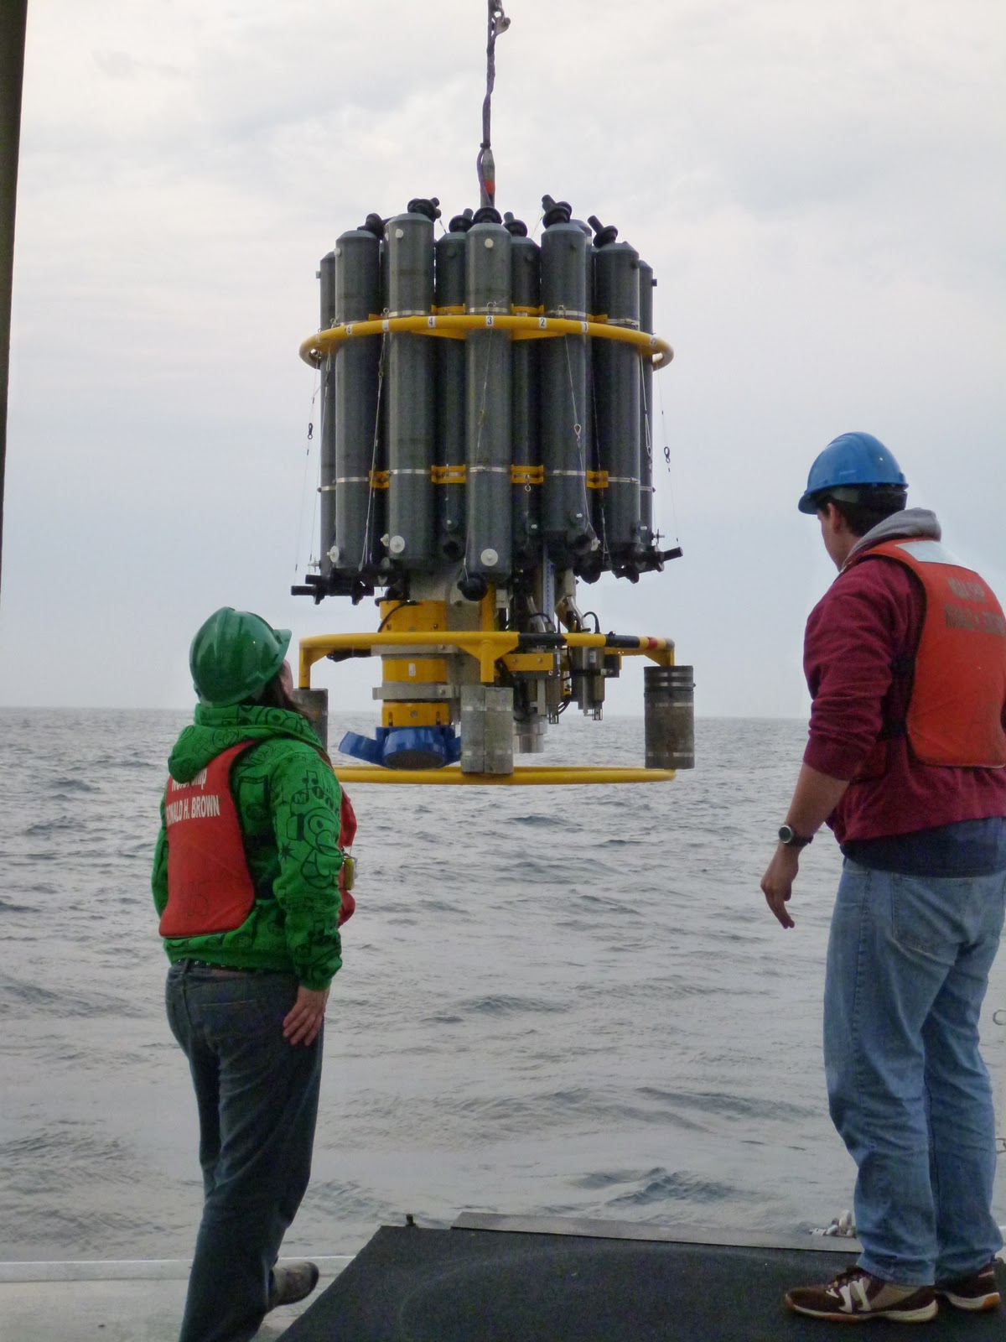
Since leaving Cape Town on September 26, we transited to shallow water off the coast of Namibia where we began lowering the CTD instrument on a cable (see attached photo) from the surface to the bottom of the ocean. The instrument also allows us to collect water samples at 24 different depths and bring the water back to the ship for chemical analysis. The work has been going well, but not at all incident free. We have had a failure and repair of the starboard thruster, a failure and repair of the aft winch braking mechanism (that allows us to lower the CTD instruments and stop to take water samples), and a failure in the forward winch level-wind (which allows the wire to lie neatly on the “spool” for re-deployment and recovery without risk of kinks and breaks in the wire). Scientific gear had some issues as well with some miscellaneous sensor hiccups that have been resolved and a more major problem with the lowered-ADCP (this is the instrument that measures deep ocean currents, visible on the attached photo as the yellow instrument with the blue “feet”); during the recovery of the CTD instrument, an unexpected roll of the ship caused a pole to accidentally knocked the lowered-ADCP battery cable lose, bending some pins. Kyle Seaton and Andy Stefanick are readying a new battery pack as I write this.

The progress of the ship along the cruise track can be monitored at the web site:
http://shiptracker.noaa.gov/ship.aspx?ship_code=RBSCSACQ&timeframe=cc&mapservice=st_nmao

One of graduate students, Elizabeth Simons, has set up a “blog” for an informal description and photos for the cruise. This blog can be accessed at:
http://clivar-a10.blogspot.com/

We anticipate completing the cruise on October 31, 2011 with a port stop in Niteroi, Brazil, just outside of Rio. We will provide weekly updates as we progress with the research.

